Paul Polsinelli

Final Project

School Threat Monitoring System

Jul 9, 2021

School Threat Monitoring System

I remember Columbine. I remember when it was an aberration. Now, shootings in the United States are frequent and just as tragic. As a parent of two elementary school children, having considered buying bulletproof backpacks for my kids, I would like to see a system that can help monitor and defeat threats to children within their schools. Although this system doesn’t strictly have to be used for schools, I am designing it with that situation in mind. Technology is powerful today. It literally has the power to save lives. I wish to design a database that could potentially be used in a real-world system to save the lives of schoolchildren under threat by being part of a system of monitoring and situational awareness. To this purpose, my proposed database will answer the following questions in real time.

1. In what security zone is the potential threat?

**SELECT LocationCode, Threat**

**FROM Threat**

**ORDER BY LocationCode**

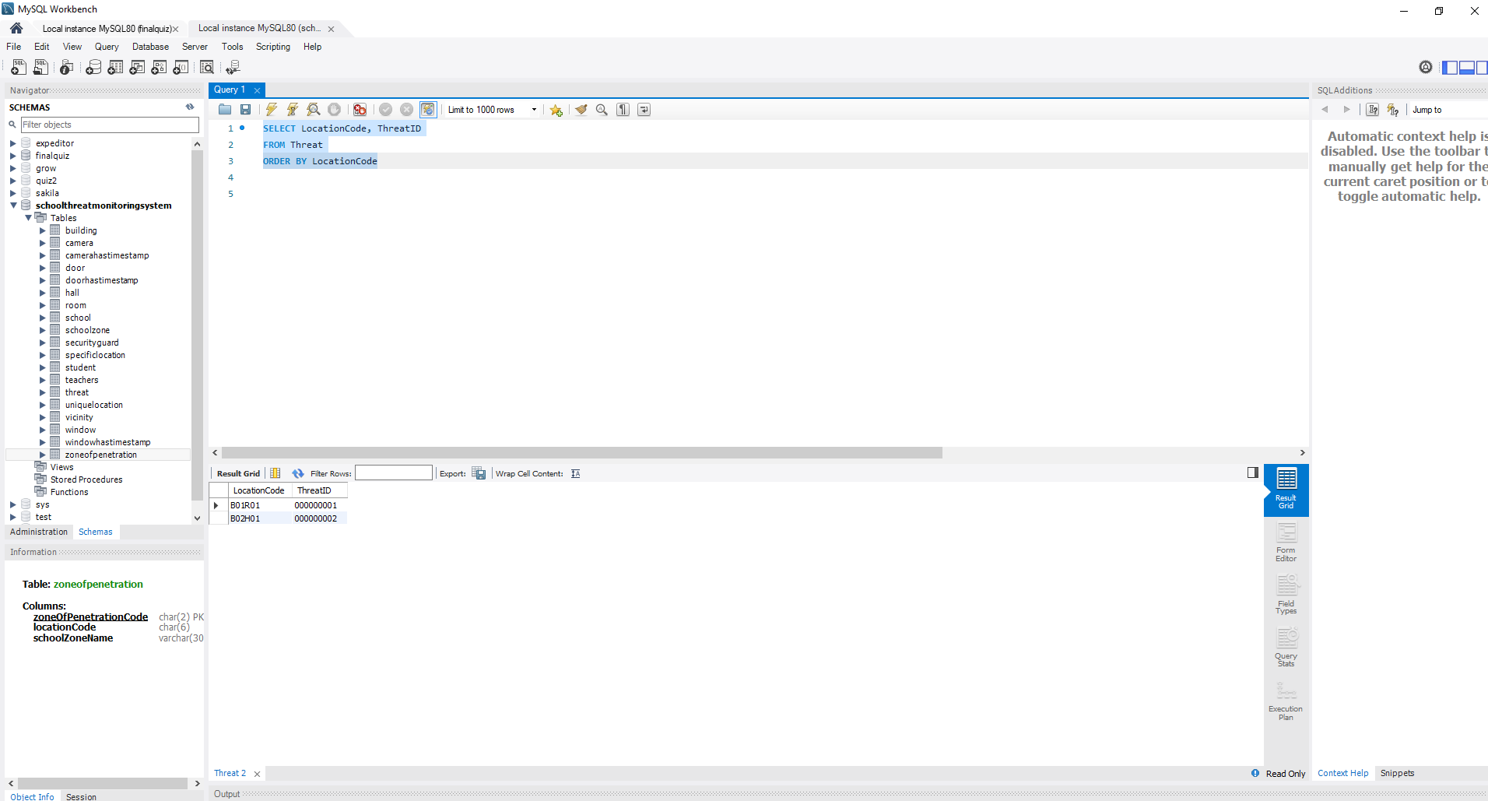

1. Has security been alerted?

**SELECT alarmProceedureCode**

**FROM School**

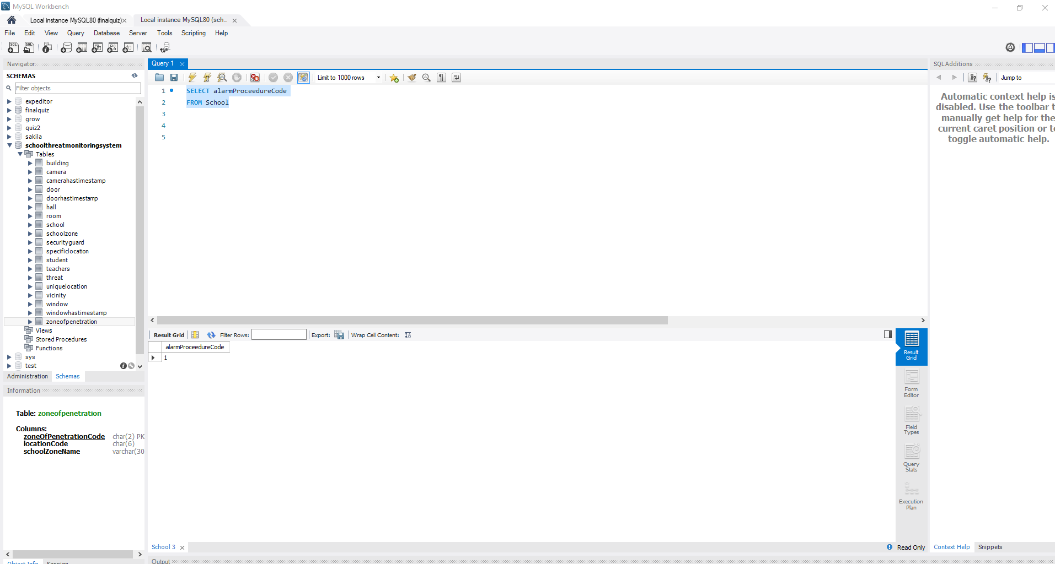

1. What is the location of security?

**SELECT LocationCode, SecurityGuardID**

**FROM SecurityGuard**

**ORDER BY LocationCode**

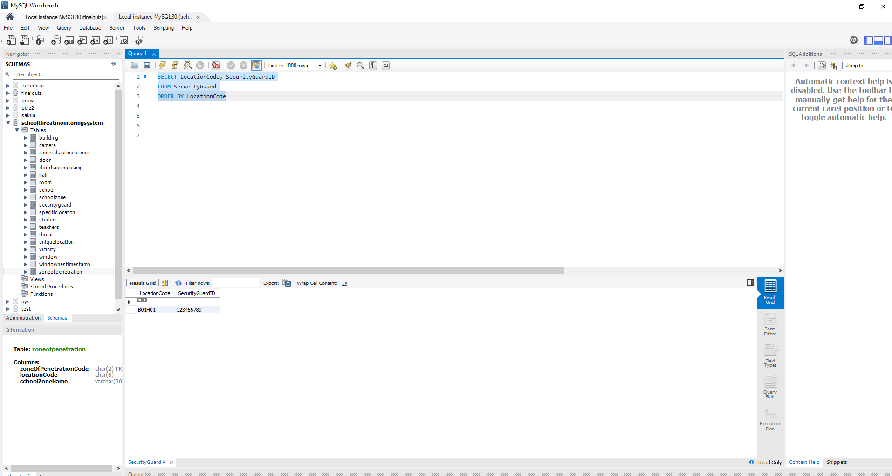

1. What is the location of the children?

**SELECT LocationCode, StudentID**

**FROM Student**

**ORDER BY LocationCode**

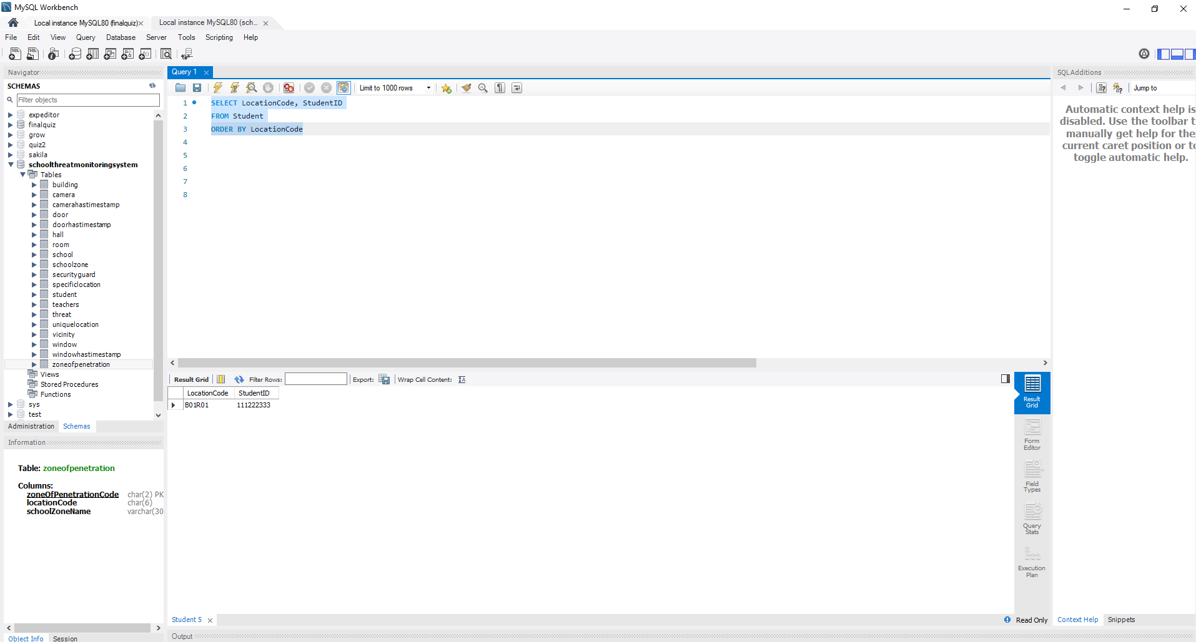

1. What is the location of the staff?

**SELECT LocationCode, TeachersID**

**FROM Teachers**

**ORDER BY LocationCode**

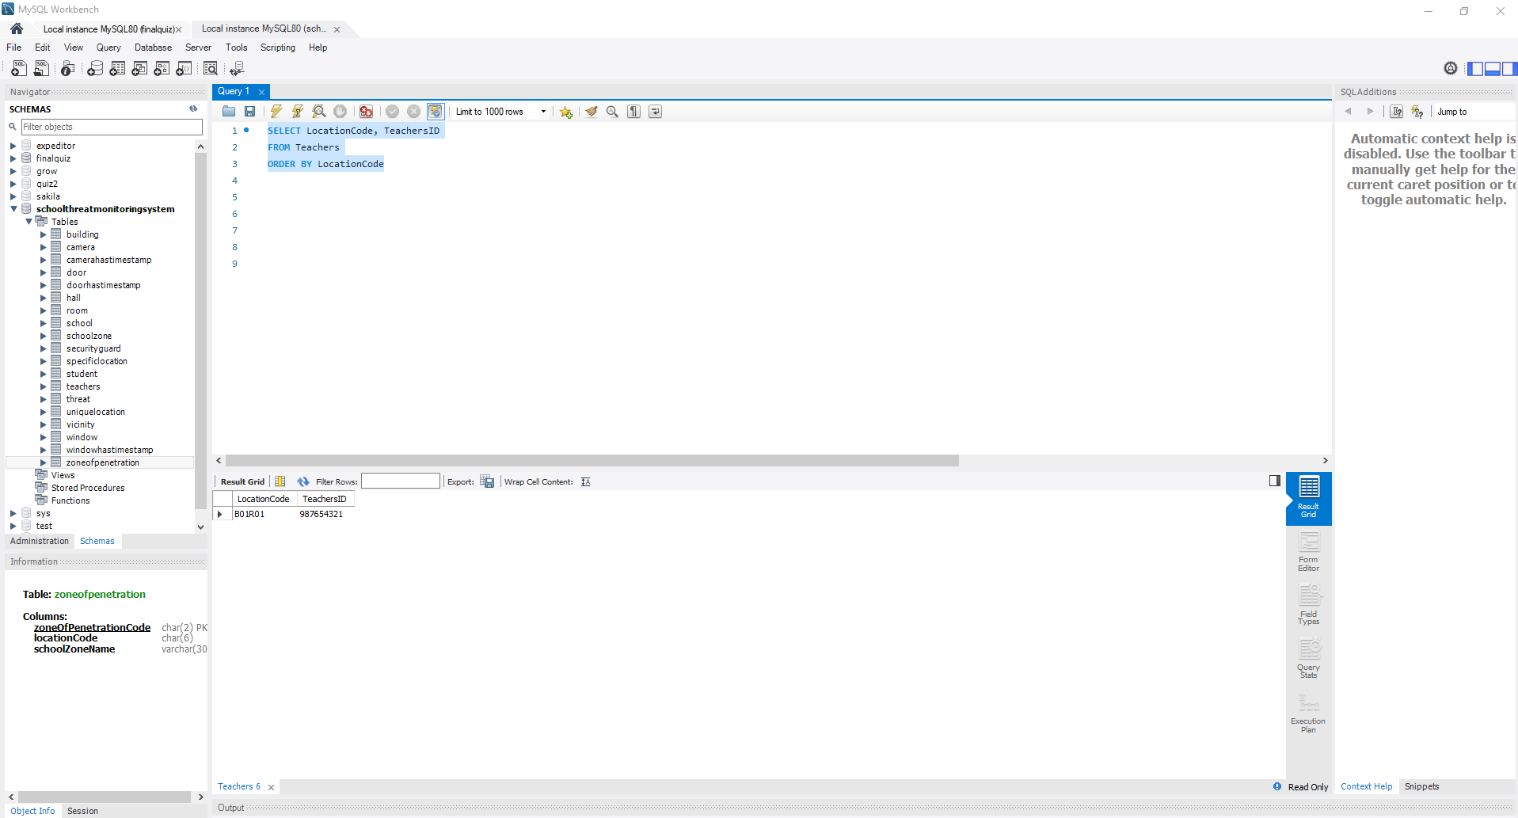

1. Has the school been breached?

**SELECT ZoneOfPenetrationCode**

**FROM ZoneOfPenetration**

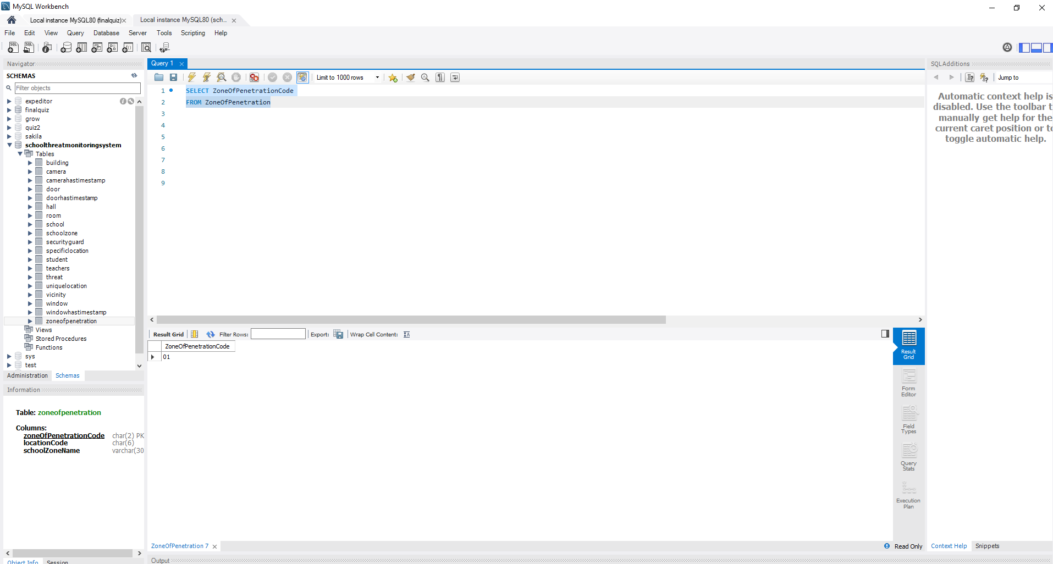

1. What is the location of the threat within the school?

**SELECT LocationCode, Threat**

**FROM Threat**

**ORDER BY LocationCode**



1. Have the police been notified?

**SELECT Call911Code**

**FROM School**

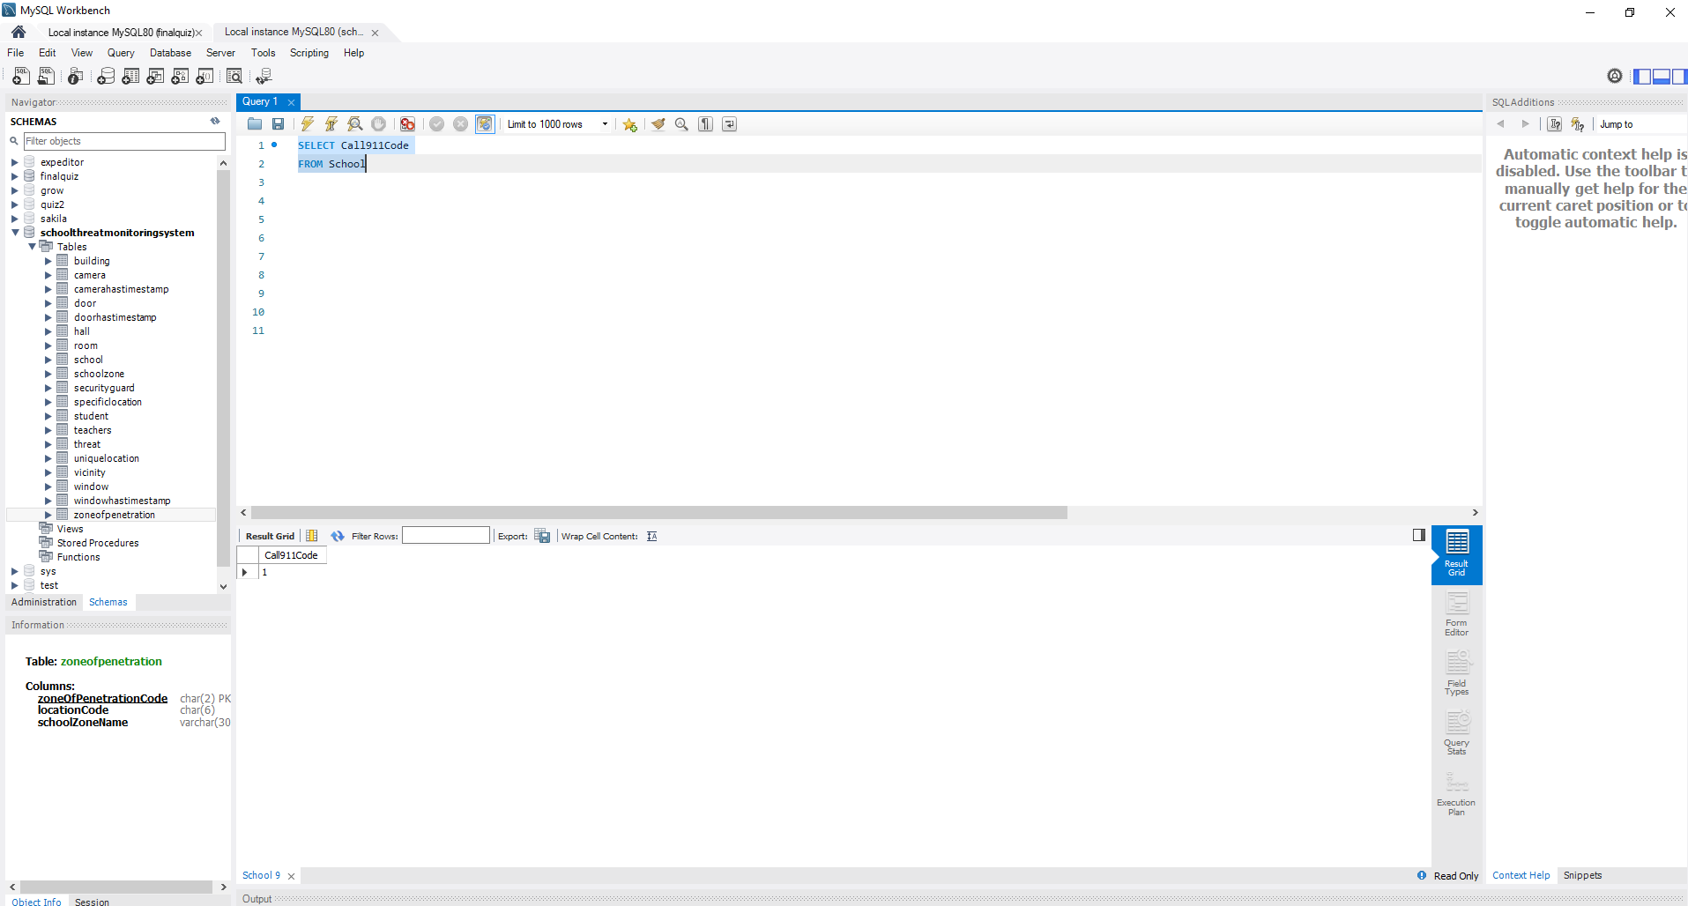

The database was designed with a two-track functionality. Being a real-time system to be used by local first responders under high stress, information is modeled around a simplified location identifier called the LocationCode. The six digits will quickly provide information on building location, room number or hallway at a glance, even without an elaborate software buildout, allowing implementation for any budget constraint. It also provides enough complexity to be used forensically on a national level with its detailed identifying codes in non-time-critical tables. The queries are meant to be simple yet precise at the same time, fitted for the circumstance of use.

In use, the cameras would identify threats starting in outer zones of penetration using AI and a software interface to write identifying information to the db with timestamps for tracking. Depending on which zone of penetration the threat is identified in, an appropriate level of alert would be issued to onsite security up to calling the local authorities. The system also tracks door and window openings.

## ORM Model

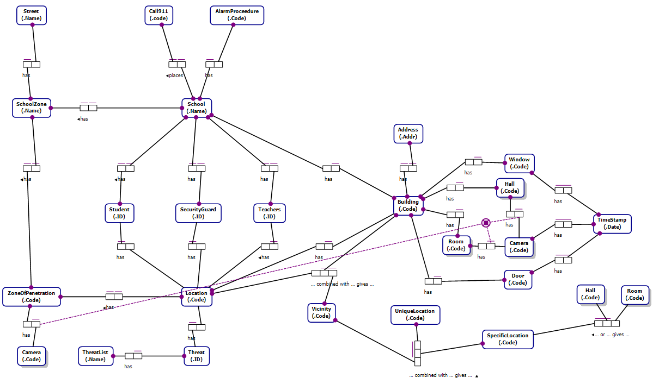

## Relational Diagram

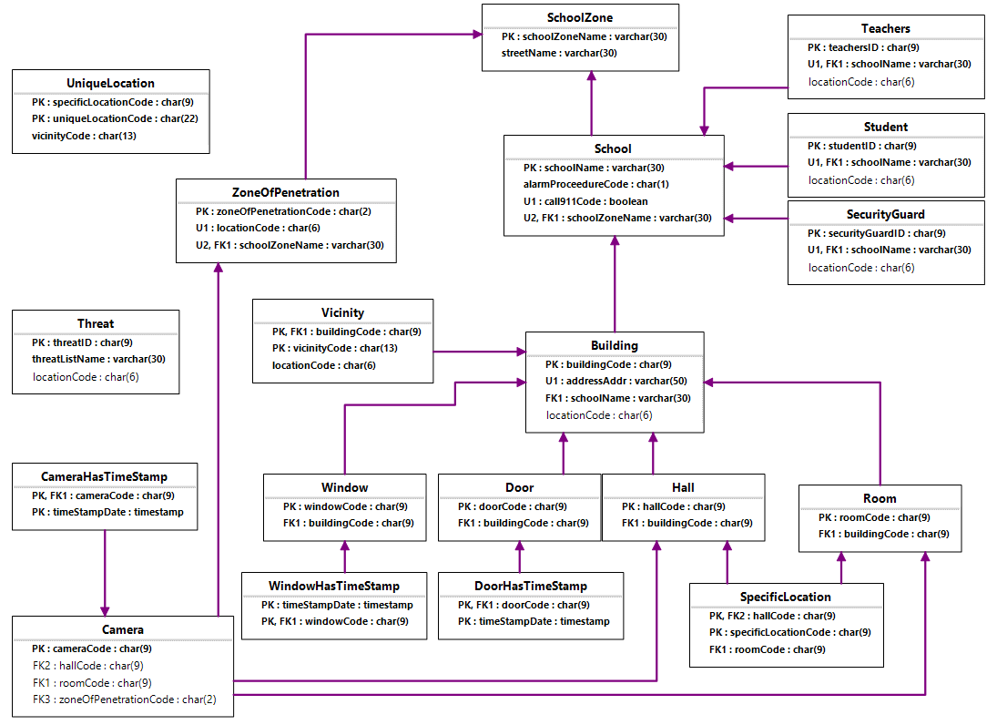

This system would require facial recognition technology as well as wireless transmission technology in addition to the software buildout. It can track movements of potential and real threats in real time and be scaled up to include any number of schools in any number of geographical areas. Use of codes as identifiers allows this scaling by providing for the ability to assign unique codes for any number of entities with alpha-numeric combinations and could easily be adjusted to provide for greater unique possibilities should the need arise.

CREATE SCHEMA `schoolthreatmonitoringsystem` ;

CREATE TABLE School

(

schoolName VARCHAR(30) NOT NULL,

alarmProceedureCode CHAR(1) NOT NULL,

call911Code BIT(1) NOT NULL,

schoolZoneName VARCHAR(30) NOT NULL,

CONSTRAINT School_PK PRIMARY KEY(schoolName),

CONSTRAINT School_UC1 UNIQUE(call911Code),

CONSTRAINT School_UC2 UNIQUE(schoolZoneName)

);

CREATE TABLE Camera

(

cameraCode CHAR(9) NOT NULL,

hallCode CHAR(9),

roomCode CHAR(9),

zoneOfPenetrationCode CHAR(2),

CONSTRAINT Camera_PK PRIMARY KEY(cameraCode)

);

CREATE TABLE SecurityGuard

(

securityGuardID CHAR(9) NOT NULL,

schoolName VARCHAR(30) NOT NULL,

locationCode CHAR(6),

CONSTRAINT SecurityGuard_PK PRIMARY KEY(securityGuardID),

CONSTRAINT SecurityGuard_UC UNIQUE(schoolName)

);

CREATE TABLE ZoneOfPenetration

(

zoneOfPenetrationCode CHAR(2) NOT NULL,

locationCode CHAR(6) NOT NULL,

schoolZoneName VARCHAR(30) NOT NULL,

CONSTRAINT ZoneOfPenetration_PK PRIMARY KEY(zoneOfPenetrationCode),

CONSTRAINT ZoneOfPenetration_UC1 UNIQUE(locationCode),

CONSTRAINT ZoneOfPenetration_UC2 UNIQUE(schoolZoneName)

);

CREATE TABLE Door

(

doorCode CHAR(9) NOT NULL,

buildingCode CHAR(9) NOT NULL,

CONSTRAINT Door_PK PRIMARY KEY(doorCode)

);

CREATE TABLE `Window`

(

windowCode CHAR(9) NOT NULL,

buildingCode CHAR(9) NOT NULL,

CONSTRAINT Window_PK PRIMARY KEY(windowCode)

);

CREATE TABLE Building

(

buildingCode CHAR(9) NOT NULL,

addressAddr VARCHAR(50) NOT NULL,

schoolName VARCHAR(30) NOT NULL,

locationCode CHAR(6),

CONSTRAINT Building_PK PRIMARY KEY(buildingCode),

CONSTRAINT Building_UC UNIQUE(addressAddr)

);

CREATE TABLE SchoolZone

(

schoolZoneName VARCHAR(30) NOT NULL,

streetName VARCHAR(30) NOT NULL,

CONSTRAINT SchoolZone_PK PRIMARY KEY(schoolZoneName)

);

CREATE TABLE Room

(

roomCode CHAR(9) NOT NULL,

buildingCode CHAR(9) NOT NULL,

CONSTRAINT Room_PK PRIMARY KEY(roomCode)

);

CREATE TABLE Hall

(

hallCode CHAR(9) NOT NULL,

buildingCode CHAR(9) NOT NULL,

CONSTRAINT Hall_PK PRIMARY KEY(hallCode)

);

CREATE TABLE Student

(

studentID CHAR(9) NOT NULL,

schoolName VARCHAR(30) NOT NULL,

locationCode CHAR(6),

CONSTRAINT Student_PK PRIMARY KEY(studentID),

CONSTRAINT Student_UC UNIQUE(schoolName)

);

CREATE TABLE Teachers

(

teachersID CHAR(9) NOT NULL,

schoolName VARCHAR(30) NOT NULL,

locationCode CHAR(6),

CONSTRAINT Teachers_PK PRIMARY KEY(teachersID),

CONSTRAINT Teachers_UC UNIQUE(schoolName)

);

CREATE TABLE Threat

(

threatID CHAR(9) NOT NULL,

threatListName VARCHAR(30) NOT NULL,

locationCode CHAR(6),

CONSTRAINT Threat_PK PRIMARY KEY(threatID)

);

CREATE TABLE WindowHasTimeStamp

(

timeStampDate DATETIME NOT NULL,

windowCode CHAR(9) NOT NULL,

CONSTRAINT WindowHasTimeStamp_PK PRIMARY KEY(windowCode, timeStampDate)

);

CREATE TABLE CameraHasTimeStamp

(

cameraCode CHAR(9) NOT NULL,

timeStampDate DATETIME NOT NULL,

CONSTRAINT CameraHasTimeStamp_PK PRIMARY KEY(cameraCode, timeStampDate)

);

CREATE TABLE DoorHasTimeStamp

(

doorCode CHAR(9) NOT NULL,

timeStampDate DATETIME NOT NULL,

CONSTRAINT DoorHasTimeStamp_PK PRIMARY KEY(doorCode, timeStampDate)

);

CREATE TABLE Vicinity

(

buildingCode CHAR(9) NOT NULL,

vicinityCode CHAR(13) NOT NULL,

locationCode CHAR(6) NOT NULL,

CONSTRAINT Vicinity_PK PRIMARY KEY(buildingCode, vicinityCode)

);

CREATE TABLE SpecificLocation

(

hallCode CHAR(9) NOT NULL,

specificLocationCode CHAR(9) NOT NULL,

roomCode CHAR(9) NOT NULL,

CONSTRAINT SpecificLocation_PK PRIMARY KEY(specificLocationCode, hallCode)

);

CREATE TABLE UniqueLocation

(

specificLocationCode CHAR(9) NOT NULL,

uniqueLocationCode CHAR(22) NOT NULL,

vicinityCode CHAR(13) NOT NULL,

CONSTRAINT UniqueLocation_PK PRIMARY KEY(uniqueLocationCode, specificLocationCode)

);

ALTER TABLE School ADD CONSTRAINT School_FK FOREIGN KEY (schoolZoneName) REFERENCES SchoolZone (schoolZoneName) ON DELETE RESTRICT ON UPDATE RESTRICT;

ALTER TABLE Camera ADD CONSTRAINT Camera_FK1 FOREIGN KEY (roomCode) REFERENCES Room (roomCode) ON DELETE RESTRICT ON UPDATE RESTRICT;

ALTER TABLE Camera ADD CONSTRAINT Camera_FK2 FOREIGN KEY (hallCode) REFERENCES Hall (hallCode) ON DELETE RESTRICT ON UPDATE RESTRICT;

ALTER TABLE Camera ADD CONSTRAINT Camera_FK3 FOREIGN KEY (zoneOfPenetrationCode) REFERENCES ZoneOfPenetration (zoneOfPenetrationCode) ON DELETE RESTRICT ON UPDATE RESTRICT;

ALTER TABLE SecurityGuard ADD CONSTRAINT SecurityGuard_FK FOREIGN KEY (schoolName) REFERENCES School (schoolName) ON DELETE RESTRICT ON UPDATE RESTRICT;

ALTER TABLE ZoneOfPenetration ADD CONSTRAINT ZoneOfPenetration_FK FOREIGN KEY (schoolZoneName) REFERENCES SchoolZone (schoolZoneName) ON DELETE RESTRICT ON UPDATE RESTRICT;

ALTER TABLE Door ADD CONSTRAINT Door_FK FOREIGN KEY (buildingCode) REFERENCES Building (buildingCode) ON DELETE RESTRICT ON UPDATE RESTRICT;

ALTER TABLE `Window` ADD CONSTRAINT Window_FK FOREIGN KEY (buildingCode) REFERENCES Building (buildingCode) ON DELETE RESTRICT ON UPDATE RESTRICT;

ALTER TABLE Building ADD CONSTRAINT Building_FK FOREIGN KEY (schoolName) REFERENCES School (schoolName) ON DELETE RESTRICT ON UPDATE RESTRICT;

ALTER TABLE Room ADD CONSTRAINT Room_FK FOREIGN KEY (buildingCode) REFERENCES Building (buildingCode) ON DELETE RESTRICT ON UPDATE RESTRICT;

ALTER TABLE Hall ADD CONSTRAINT Hall_FK FOREIGN KEY (buildingCode) REFERENCES Building (buildingCode) ON DELETE RESTRICT ON UPDATE RESTRICT;

ALTER TABLE Student ADD CONSTRAINT Student_FK FOREIGN KEY (schoolName) REFERENCES School (schoolName) ON DELETE RESTRICT ON UPDATE RESTRICT;

ALTER TABLE Teachers ADD CONSTRAINT Teachers_FK FOREIGN KEY (schoolName) REFERENCES School (schoolName) ON DELETE RESTRICT ON UPDATE RESTRICT;

ALTER TABLE WindowHasTimeStamp ADD CONSTRAINT WindowHasTimeStamp_FK FOREIGN KEY (windowCode) REFERENCES `Window` (windowCode) ON DELETE RESTRICT ON UPDATE RESTRICT;

ALTER TABLE CameraHasTimeStamp ADD CONSTRAINT CameraHasTimeStamp_FK FOREIGN KEY (cameraCode) REFERENCES Camera (cameraCode) ON DELETE RESTRICT ON UPDATE RESTRICT;

ALTER TABLE DoorHasTimeStamp ADD CONSTRAINT DoorHasTimeStamp_FK FOREIGN KEY (doorCode) REFERENCES Door (doorCode) ON DELETE RESTRICT ON UPDATE RESTRICT;

ALTER TABLE Vicinity ADD CONSTRAINT Vicinity_FK FOREIGN KEY (buildingCode) REFERENCES Building (buildingCode) ON DELETE RESTRICT ON UPDATE RESTRICT;

ALTER TABLE SpecificLocation ADD CONSTRAINT SpecificLocation_FK1 FOREIGN KEY (roomCode) REFERENCES Room (roomCode) ON DELETE RESTRICT ON UPDATE RESTRICT;

ALTER TABLE SpecificLocation ADD CONSTRAINT SpecificLocation_FK2 FOREIGN KEY (hallCode) REFERENCES Hall (hallCode) ON DELETE RESTRICT ON UPDATE RESTRICT;

ALTER TABLE `schoolthreatmonitoringsystem`.`school`

CHANGE COLUMN `schoolName` `schoolName` VARCHAR(30) NOT NULL DEFAULT 'School' ,

CHANGE COLUMN `alarmProceedureCode` `alarmProceedureCode` CHAR(1) NOT NULL DEFAULT 0 ,

CHANGE COLUMN `call911Code` `call911Code` BIT(1) NOT NULL DEFAULT 0 ;

ALTER TABLE `schoolthreatmonitoringsystem`.`camera`

CHANGE COLUMN `cameraCode` `cameraCode` CHAR(9) NOT NULL DEFAULT '000000000' ;

ALTER TABLE `schoolthreatmonitoringsystem`.`securityguard`

CHANGE COLUMN `securityGuardID` `securityGuardID` CHAR(9) NOT NULL DEFAULT '000000000' ;

ALTER TABLE `schoolthreatmonitoringsystem`.`zoneofpenetration`

CHANGE COLUMN `zoneOfPenetrationCode` `zoneOfPenetrationCode` CHAR(2) NOT NULL DEFAULT '00' ,

CHANGE COLUMN `locationCode` `locationCode` CHAR(6) NOT NULL DEFAULT '000000' ;

ALTER TABLE `schoolthreatmonitoringsystem`.`door`

CHANGE COLUMN `doorCode` `doorCode` CHAR(9) NOT NULL DEFAULT '000000000' ;

ALTER TABLE `schoolthreatmonitoringsystem`.`window`

CHANGE COLUMN `windowCode` `windowCode` CHAR(9) NOT NULL DEFAULT '000000000' ;

ALTER TABLE `schoolthreatmonitoringsystem`.`building`

CHANGE COLUMN `buildingCode` `buildingCode` CHAR(9) NOT NULL DEFAULT '000000000' ,

CHANGE COLUMN `addressAddr` `addressAddr` VARCHAR(50) NOT NULL DEFAULT '123 Main St.' ;

ALTER TABLE `schoolthreatmonitoringsystem`.`schoolzone`

CHANGE COLUMN `schoolZoneName` `schoolZoneName` VARCHAR(30) NOT NULL DEFAULT 'School Zone' ,

CHANGE COLUMN `streetName` `streetName` VARCHAR(30) NOT NULL DEFAULT 'Street' ;

ALTER TABLE `schoolthreatmonitoringsystem`.`room`

CHANGE COLUMN `roomCode` `roomCode` CHAR(9) NOT NULL DEFAULT '000000000' ;

ALTER TABLE `schoolthreatmonitoringsystem`.`hall`

CHANGE COLUMN `hallCode` `hallCode` CHAR(9) NOT NULL DEFAULT '000000000' ;

ALTER TABLE `schoolthreatmonitoringsystem`.`student`

CHANGE COLUMN `studentID` `studentID` CHAR(9) NOT NULL DEFAULT '000000000' ;

ALTER TABLE `schoolthreatmonitoringsystem`.`teachers`

CHANGE COLUMN `teachersID` `teachersID` CHAR(9) NOT NULL DEFAULT '000000000' ;

ALTER TABLE `schoolthreatmonitoringsystem`.`threat`

CHANGE COLUMN `threatID` `threatID` CHAR(9) NOT NULL DEFAULT '000000000' ,

CHANGE COLUMN `threatListName` `threatListName` VARCHAR(30) NOT NULL DEFAULT 'Threat List' ;

ALTER TABLE `schoolthreatmonitoringsystem`.`vicinity`

CHANGE COLUMN `vicinityCode` `vicinityCode` CHAR(13) NOT NULL DEFAULT '0000000000000' ;

ALTER TABLE `schoolthreatmonitoringsystem`.`specificlocation`

CHANGE COLUMN `specificLocationCode` `specificLocationCode` CHAR(9) NOT NULL DEFAULT '000000000' ;

ALTER TABLE `schoolthreatmonitoringsystem`.`uniquelocation`

CHANGE COLUMN `specificLocationCode` `specificLocationCode` CHAR(9) NOT NULL DEFAULT '000000000' ,

CHANGE COLUMN `uniqueLocationCode` `uniqueLocationCode` CHAR(22) NOT NULL DEFAULT '0000000000000000000000' ;

ALTER TABLE `schoolthreatmonitoringsystem`.`specificlocation`

CHANGE COLUMN `hallCode` `hallCode` CHAR(9) NOT NULL DEFAULT '000000000' ,

CHANGE COLUMN `roomCode` `roomCode` CHAR(9) NOT NULL DEFAULT '000000000' ;

